Newsletter for May 2018
South Kingstown Forest Fire Dept.
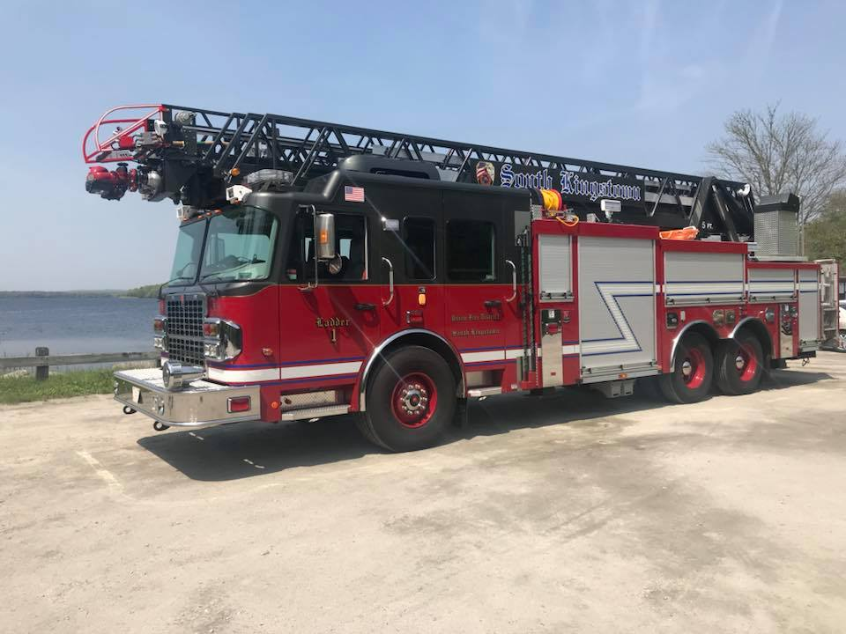

Upcoming Events

June 2
Special Olympics at Sta3

June 3
Ropes class with DC6

June 6
Elevator class with KFD
June 13
Bailout class
June 25
Next Station meeting 730pm

May Birthdays!!!
Brett Whaley
Matthew McDermott
Happy Birthday to all!

36 School Street South Kingstown, RI. 02879
WWW.SKFFS.Org (401)-783-3231
Dear Member,
Welcome to our monthly newsletter for the station!! This is designed to help spread the word of all the news and event that is happening at Forestry. If anyone has something they would like to see published to this letter please send an email to Vice President Maine and we will make sure its makes the list.

Golf Tournament coming soon!!
The Station is working on an 18 hole golf tournament with dinner in the month of June. We will need all hands on deck gathering raffle prizes and Tee sponsors. If you know any business owners try to get them to sponsor a hole!! Lt. McCallig is the point person for this event. We really need to get into crunch mode with this event, we still have room for golfers and we really need to secure more sponsors. Please get out there and help the station out.

Equipment changes to the Ladder Truck.
Over the past few days some changes have been made to the compartment spaces on the ladder 1. We are finding the original design didn’t support the mission for what our firefighters want to do best and excel at. The station has jumped many hurdles since the ladder arrived and everyone’s determination to be a great ladder company continues. With these changes we hope to add more equipment that will help us be successful when we are called into action. The biggest change has occurred in the biggest transverse compartment of the truck. The stokes and 8ft ladder now rest under the stick and we hope to add another sliding shelve into the compartment area. If you have ideas or request for equipment please let the officers know.

Events and District News
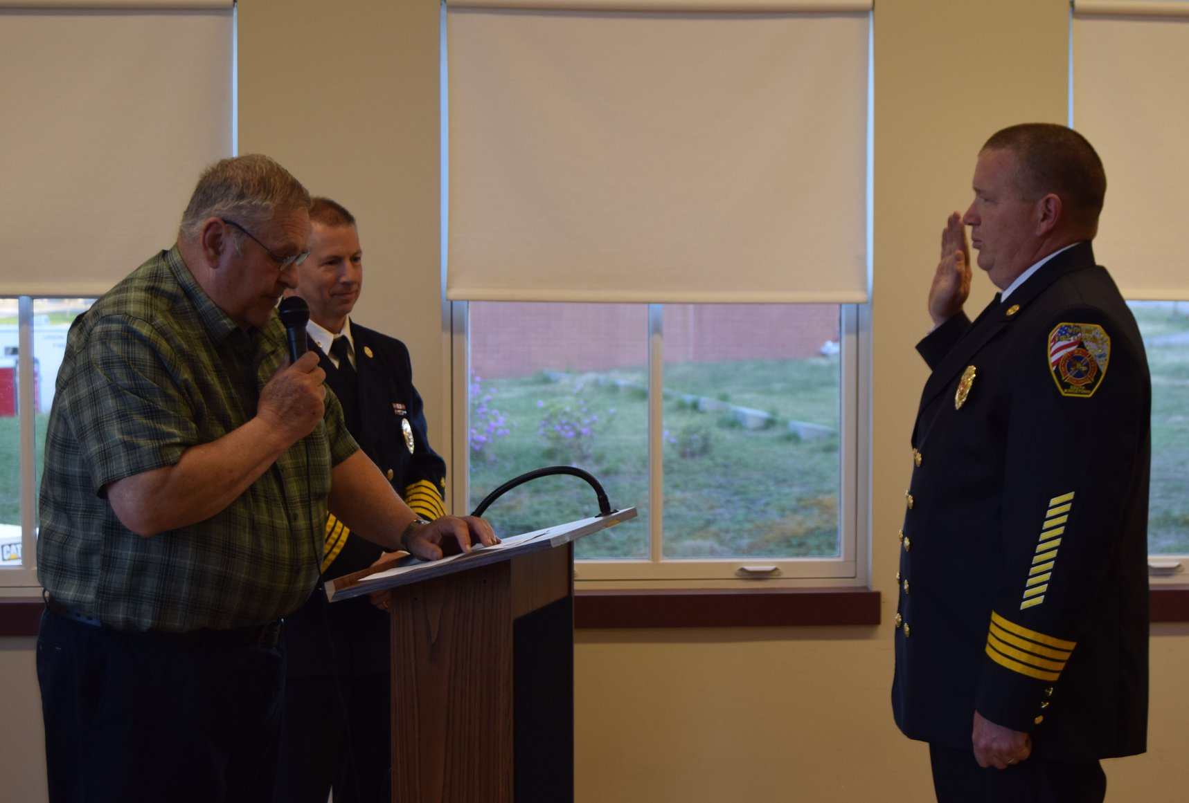

Recent Fire Calls

140 Old tower hill rd.
Ladder 1 and Car 21 responded to the McDonald’s for an alarm sounding. After an investigation it was determined the HVAC on the roof had a malfunction. Ladder 1 secured the unit without issue and the system reset.

145 Chickadee Lane
Brush 4 responded to a possible brush fire in the area of. On arrival it was determined that a stump dump in the gravel bank was smoldering. C5 advised to let it burn as it was contained and no threat to spread.
Town of Narragansett
Ladder 1 responded twice in the past week to assist on a box alarm at the rite aid and then on a smoke in the building call at the Marshalls both in the plaza on woodruff Ave. The box was caused by a sprinkler issue and the smoke in the building was possibly caused from a roof top unit.

On June 1st DC Tom Bradley will officially be taking part in his new role as chief 6. Tom is a long time district member coming out of Peace Dale Fire. DC Bradley is filling the spot by now retired DC Richard Collinson. We wish Tom the best as he starts a new chapter of his UFD career and we wish DC Richard Collinson nothing but the best in his retirement. DC Collinson was a great chief, and will be greatly missed at department events and functions. Richard still plans to help with Greek week the next time we have visitors from out of the country.

On May 16th LT. Keith Maine was appointed to the position of Battalion Chief. This position was created when Tom Bradley got promoted to the roll of DC. LT. Maine competed with 2 other district officers for the position and came out on top and was notified by Chief Pinch of his selection and start date. Congrats on the new position.

On June 2nd the RI Special Olympics will be using the station as a staging area for their athletes who are competing in the bowling event which is taking place at Old Mountain Lanes. A few members are requested to be present the day of to help the special Olympic staff. If you can attend please let the Captain know.

We thank you!
Thank you to the Engineers for all 3 trucks for keeping them in order
Thanks to Will, Joe & Keith for taking the lead on the southern league class
Thank you to Don for keeping the station looking clean
Thank you to Colby, James, Dan & Keith for keeping the duty engine staffed on Mondays and Thursdays

Station 3 Upcoming Trainings
On June 3rd we will be working with the Kingston Fire Dist. on elevator rescues. Please make every attempt to be at this class. We don’t get to practice these type of calls often so it benefits everyone to stay fresh on how these systems work, and how we attempt victim extrication in certain scenarios.

On June 13th BC Kevin Jutras from PFD will be instructing a basic bailout class for those who want to learn this technique. He will go over the steps to bail out of a window in a firefighter self-rescue scenario. All are urged to attend to at least see how perform the maneuver and to see what steps you can do from the outside to help a member who is quickly coming out of a window in need of help.

Two weekends ago 4 station members took a class in Providence on lifting, stabilization and vehicle extrication. This class showed how to lift all sorts of vehicles so you can properly remove an injured party. They were shown the advantages of Paratech struts, airbags, grip hoist and other tools used to shore up vehicle. On Day 2 they used the information and skills from day 1 and mixed in cutting and spreading cars with Genesis battery operated Jaws of Life equipment. It was a very informative class and all members got to play with some new equipment and learned some new ideas for approaching these types of emergencies we respond to. Thank you Brett, Colby, Will & Keith for taking time out of your weekend to attend this 2 day 16 hour training. Photos from class have been posted on the Stations Facebook page.

Volunteer Showcase
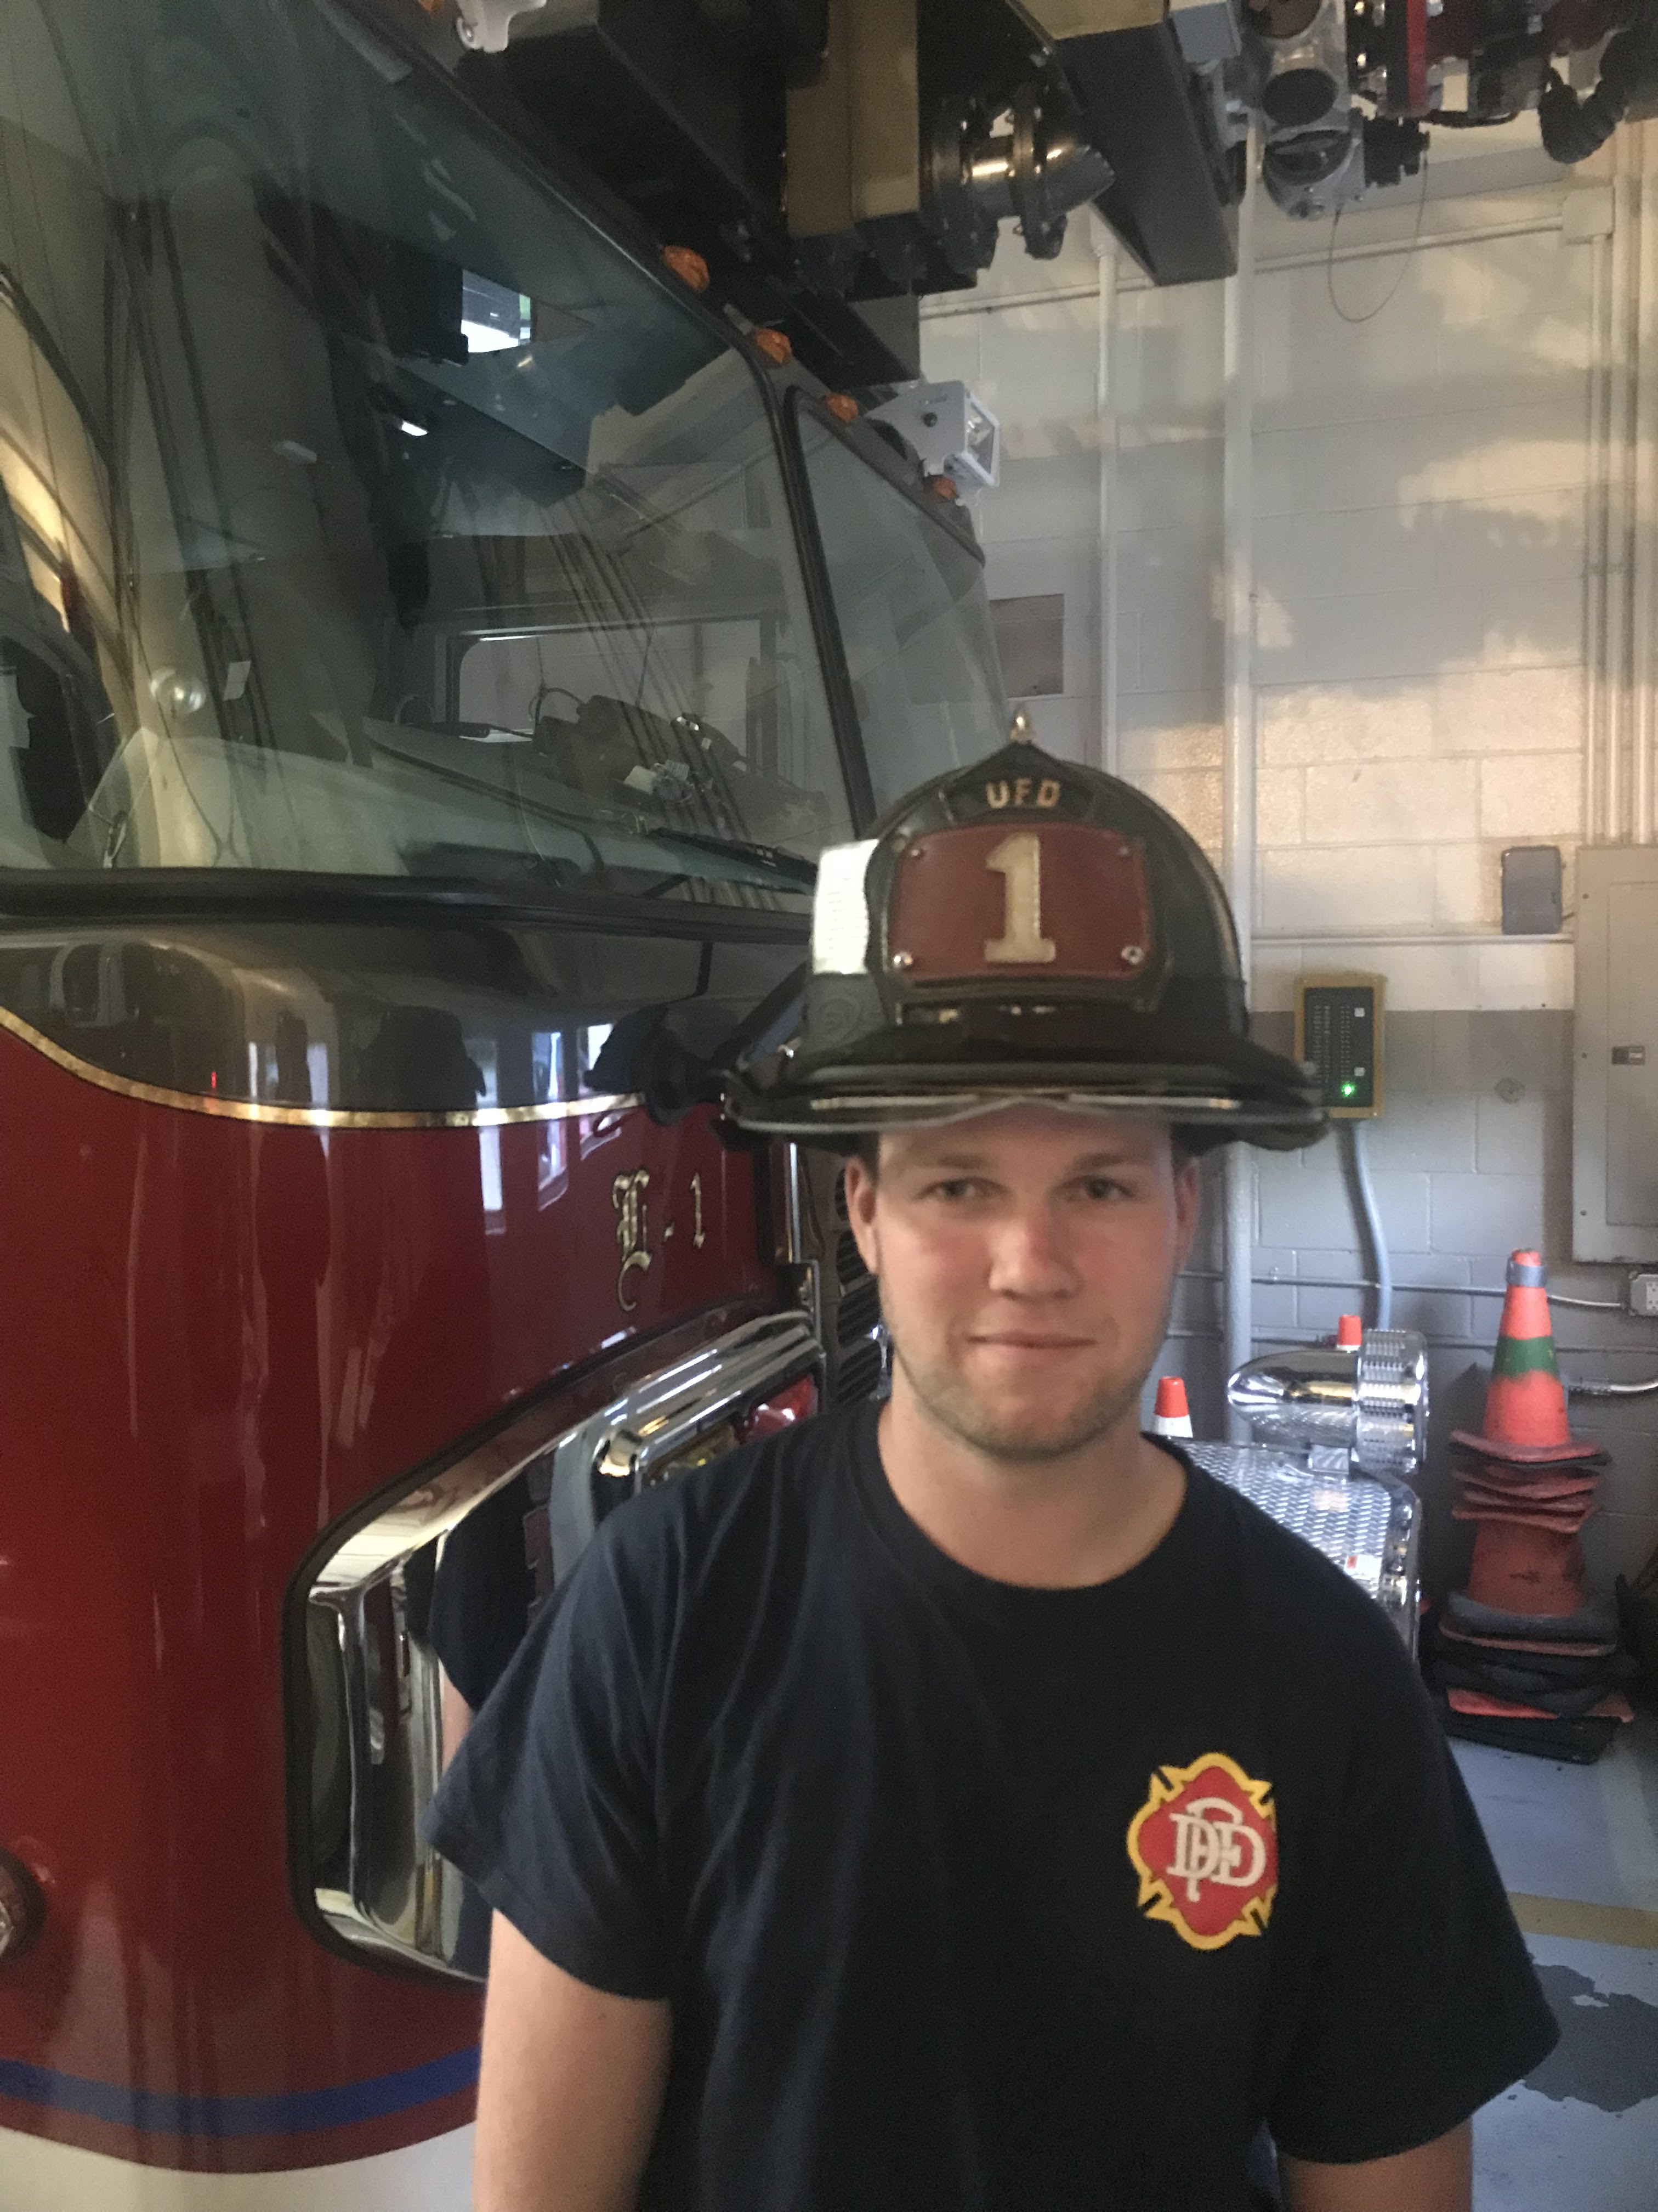
This month’s featured Volunteer is James Fareless. James has been a volunteer firefighter since the age of 16 and joined the department in 2012. James graduated from South Kingstown High school in 2016 and is currently enrolled at the University of Rhode Island studying Marine Affairs. A few months ago James decided to join our armed services and will be heading off to boot camp for the US Air Force. James is currently training to become a driver/operator of the trucks in the station. He was awarded Probie of the year during his last year on probation and also received an award for most runs for the year of 2015. His most rewarding moment being a volunteer firefighter is when he got to assist in the extrication of 4 young adults from a car that was in a ditch on its roof off the highway. A fun fact about James is that he claims to be the best fisherman and golfer in the station… Thank you James for your continued effort in providing nothing but the finest of public service to our citizens. Next month we will continue to spotlight our members active, life and associate.

