Newsletter for April 2018
South Kingstown Forest Fire Dept.
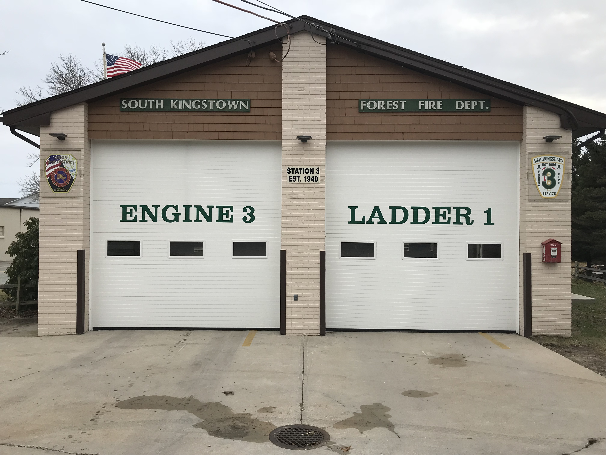

Upcoming Events

April 21
EVOC class at KFD 8am Sta4

April 30
Station Monthly Meeting 730PM

May 15
Station to host a southern league drill at the classroom 7pm

April Birthdays !!!
Joe Notarantonio IV
James Haitz
Frank Livolsi
Bernie Hammond
Christa Poulos
Happy Birthday to all!

36 School Street South Kingstown, RI. 02879
WWW.SKFFS.Org (401)-783-3231
Dear Member,
Welcome to our monthly newsletter for the station!! This is designed to help spread the word of all the news and event that is happening at Forestry. If anyone has something they would like to see published to this letter please send an email to Vice President Maine and we will make sure its makes the list.

Golf Tournament coming soon!!
The Station is working on an 18 hole golf tournament with dinner in the month of June. We will need all hands on deck gathering raffle prizes and Tee sponsors. If you know any business owners try to get them to sponsor a hole!! Lt. McCallig is the point person for this event. Any questions, comments or suggestions should go to him. We have started to secure sponsors !! It is vital everyone can get out and get sponsors so we can bring in easy money.

Engines have been swapped over for brush season.
Last week station members worked to get the Brush unit and Engine ready for the upcoming brush fire season. All the ice gear has been removed and the cold water suits are still available next to the brush truck for any water incidents that might occur in the next few months until the water warms up. Take a few minutes to review both Brush 4 and Engine 3 for equipment location.

Events and District News
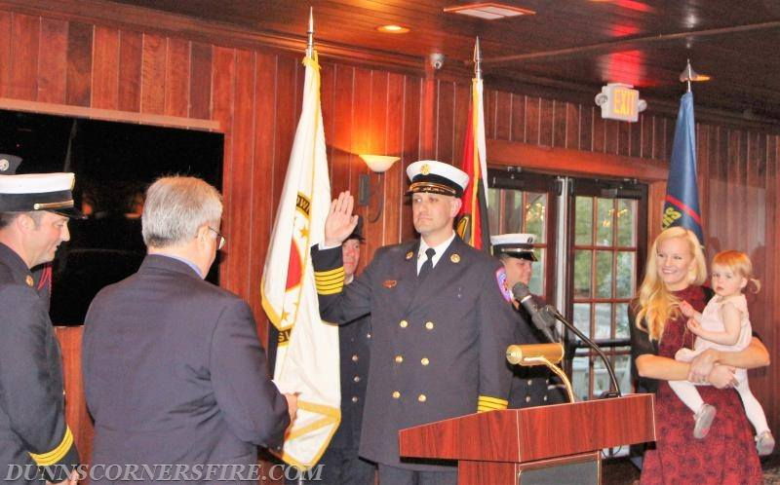

Recent Fire Calls

344 Main Street
Box alarm response last week proves a dusty mess for the crew of engine 3. Workers in the basement level managed to set off the 3rd floor smoke with a dust bowl that took positive and negative ventilation to clear the building.

81 Canterberry Rd.
Ladder 1 responded with the South units for a possible pellet stove fire. On arrival the ladder conducted positive ventilation and assisted interior units with C/O readings and securing the stove. The fire was contained to the fire box and actually had a mechanical failure with its venting system.
1223 Saugatucket Rd
A full response was sent for smoke in the hallway at the Peace Dale Estates. Smoke was coming from a heating element which was overheating and needed cleaning.

On April 6th the UFD chiefs with members of Station 3 attended the pining ceremony for newly appointed Dunns Corner Fire District Chief Christopher Degrave. Chief Degrave was a DC at the Kingston Fire District, and a member for more than a decade. The Chief has helped the officers of the station develop our current training packet for recruits and active firefighters. Chris was always willing to assist our station with trainings and for that we are very grateful and wish him the best on his new endeavors.

During the Month of March and April the Fire District started its search for the next Deputy Chief. DC Collinson is retiring in June. The District went with an outside interview committee which interviewed 6 UFD candidates for the position. Out of those 6 the field was reduced to the top 3 for consideration with the board of wardens and the chief. The final selection of the position of awarded to LT Tom Bradley from Peace Dale and his appointment will be later in May. On the bright side Capt. Notarantonio and LT. Maine both we considered as they landed positions in the top 3. Even though they did not get the position their representation in the top 3 is a great sign for our future as a station and district. Congrats to both of them for finishing so well.

We thank you!
Thank you to Colby for the continued work with the ladder organization.
Thanks to Will for doing the leg work and submitting the equipment quote needed for the southern league class.
Thank you to Don for keeping the station looking clean
Thank you to Colby, James, Dan & Keith for keeping the duty engine staffed on Mondays and Thursdays
Station 3 Upcoming Trainings
Station members are attending an EVOC driver’s instructor’s course provided by VFIS insurance company on April 21 & 22. This is a 16 hour course and will certify attendees to properly instruct drivers on defensive, offensive and how to evade situations.

Drills are currently still being held on Wednesdays at 1830hrs and Sundays at 0930. The Sundays are showing to be pivotal for the recruits as they are being taught the basics and are improving slowly.

May 11th the RI fire academy in Exeter is hosting a FREE seminar on Ethanol safety. The class runs 8am til 430pm. Lunch is provided and attendees will be provided with a certificate for the training.

May 15th the station is hosting a Southern League training night at the Administration building. The topic that night will be Standpipe operations. The Classroom portion of the class is being instructed by the Captain and LT Maine. After the classroom the members of the station will give demonstrations on standpipe use and hose line advancement using multiple methods.
The weekend of May 19th-20th members will be attending a Heavy Rescue class in Providence hosted by New England Fire Equipment, Connecticut Custom Fire Training and American Safety programs. They will be attending classes in Vehicle extrication, Lifting and stabilization & Machinery rescue.

Volunteer Showcase 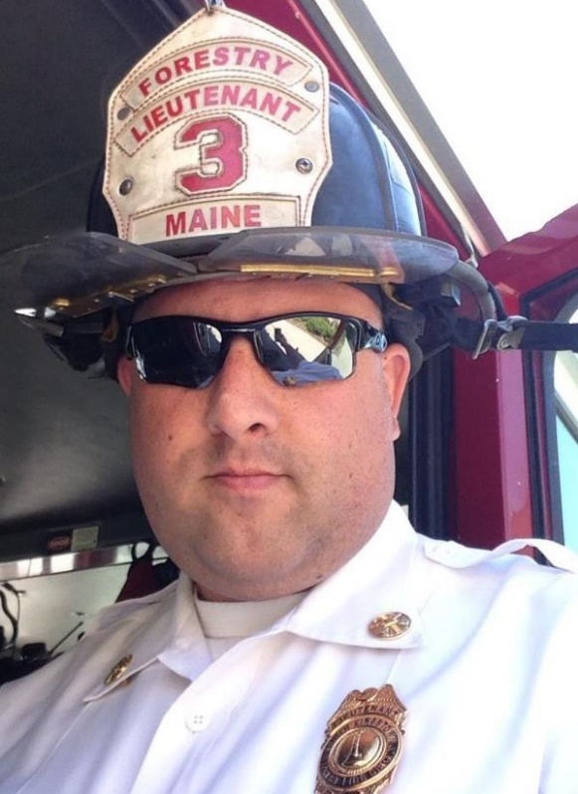
This monthly Volunteer spotlight will be on Lieutenant Keith E. Maine. Keith has been a member of the South Kingstown Forest Fire Service since Oct 1996. Keith is a life member and will be completing 22 years of service this October. He currently serves as the Vice President of board and has also held the position of secretary. Keith has been an officer of the department for the past 10 years as a Lieutenant & was acting department Captain. Keith is a graduate of SKHS class of 1999. He continued his education at CCRI where he started his Fire Science degree. He is currently enrolled at the University of Southern Columbia and on pace to complete his B.S. in Fire Administration. Keith currently works at the Watch Hill Fire department as a firefighter/Fire Mashal and before that he retired from the city of Providence after 17 years in which he was a Police dispatcher, training officer and ending his career as the senior fire alarm inspector/ ADSFM with the the City of Providence Fire Alarm Division. LT. Maine is currently 1001,1002,1031,1041 and UFD 1403 certified with pro-board certificates. He also holds many other FEMA, IFSTA and NFPA certifications. The Lieutenants most achieving moment as a firefighter occurred in the winter of 2009, when he and another firefighter were first on scene at a structure fire. Their quick action in alerting the sleeping residence lead to the successful rescue of 3 occupants, 2 of which jumped from a second floor bedroom into his arms and one escorted out the front door. Because of this the District awarded him with the “heroic action award”. Keith continues to be an active drive in the fire side and is slated to be married this June. Next month we will continue to spotlight our members active, life and associate.

